PERFORMANCE EVALUATION OF AM GENERATION AND DETECTION UNDER NOISY CHANNEL CONDITIONS USING MATLAB
Analog and Digital Communication — Experiment 9
Date of Experiment | 12/10/2026
Performed By | Lokesh A
Register Number | 192512293
1. Aim
To generate an amplitude-modulated (AM) signal, add additive white Gaussian noise (AWGN), and observe the effect of channel noise on envelope detection and recovered-signal quality using MATLAB.
2. MATLAB Program
clc;
clear;
close all;
% Parameters
fs = 100000;
t = 0:1/fs:0.02;
fm = 500;
fc = 5000;
% Message Signal
m = cos(2*pi*fm*t);
c = cos(2*pi*fc*t);
% AM Modulation
am = (1 + m).*cos(2*pi*fc*t);
% Add AWGN Noise
noisy = awgn(am,10,'measured'); % 10 dB SNR
% Envelope Detection
env = abs(hilbert(noisy));
% Display Results
figure;
subplot(5,1,1)
plot(t,m)
title('Message Signal')
grid on
subplot(5,1,2)
plot(t,c)
title('Carrier Signal')
grid on
subplot(5,1,3)
plot(t,am)
title('AM Signal')
grid on
subplot(5,1,4)
plot(t,noisy)
title('AM Signal with AWGN Noise')
grid on
subplot(5,1,5)
plot(t,env)
title('Recovered Signal')
grid on
3. Output
The plots show the message signal, carrier signal, AM signal, AM signal after adding AWGN noise, and the envelope-detected recovered signal. Noise causes visible fluctuations in the received waveform and in the recovered envelope.
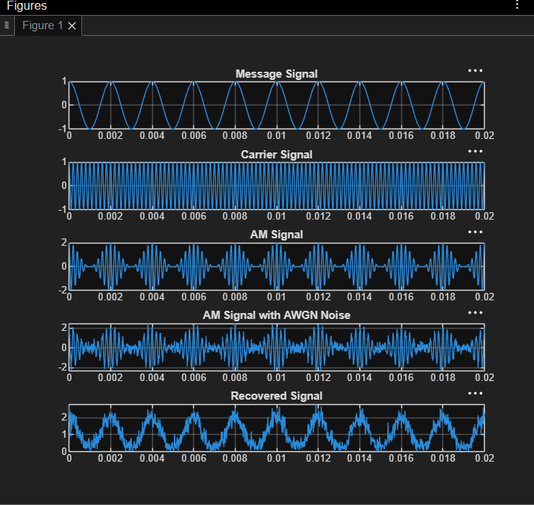
Figure 1. MATLAB output showing the message, carrier, AM, noisy AM and recovered signals.
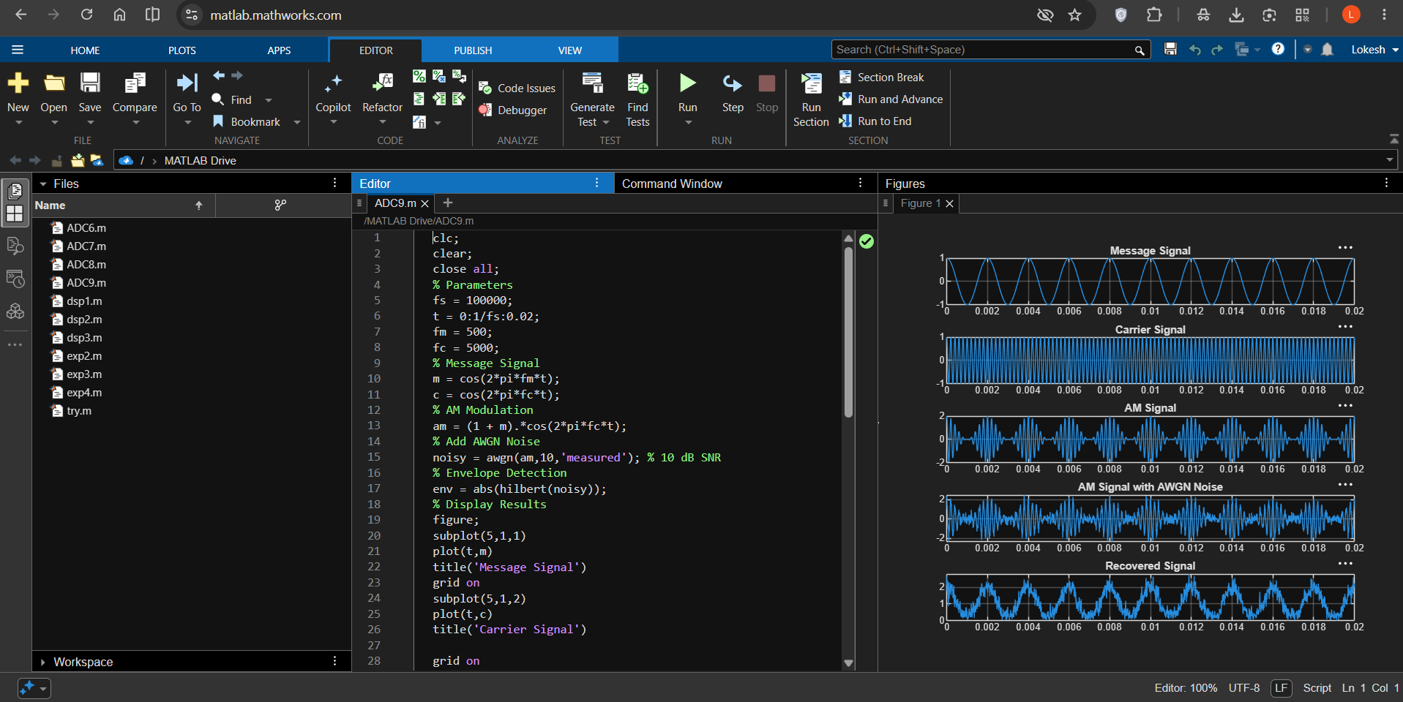
Figure 2. MATLAB editor and graphical output for AM detection under AWGN noise.
4. Simulation Parameters and Results
Parameter | Value
Sampling frequency (fs) | 100,000 Hz
Message frequency (fm) | 500 Hz
Carrier frequency (fc) | 5,000 Hz
Simulation duration | 0.02 s
Channel noise model | Additive White Gaussian Noise (AWGN)
Signal-to-noise ratio (SNR) | 10 dB
Detection method | Envelope detection using abs(hilbert(noisy))
5. Applications
- Studying AM receiver performance in the presence of channel noise.
- Evaluating envelope detection in basic AM communication systems.
- Communication-system simulation and receiver testing under controlled noise conditions.
- Demonstrating the relationship between signal-to-noise ratio and recovered-signal quality.
6. Alignment with Analog and Digital Communication
This experiment relates to amplitude modulation, channel noise, signal-to-noise ratio and envelope detection. MATLAB is used to generate an AM waveform, contaminate it with AWGN, and visualize the received waveform and its detected envelope.
ADC Concept | Implementation | Observed Output
Message signal | m = cos(2*pi*fm*t) | Message Signal plot
Carrier signal | c = cos(2*pi*fc*t) | Carrier Signal plot
AM generation | am = (1 + m).*cos(2*pi*fc*t) | AM Signal plot
Noisy channel | awgn(am,10,'measured') | AM Signal with AWGN Noise plot
Envelope detection | abs(hilbert(noisy)) | Recovered Signal plot
SNR setting | 10 dB | Noise added at the specified SNR
7. Justification
- The original message and carrier plots establish the input signals used to generate AM.
- The AM plot shows the modulated waveform before channel noise is introduced.
- AWGN models random noise affecting the transmitted signal during communication.
- The noisy waveform and detected envelope allow visual assessment of the effect of noise on recovery.
- The simulation provides a repeatable way to study receiver behavior under a specified SNR.
8. Conclusion
An AM signal was generated in MATLAB and passed through a simulated AWGN channel with an SNR setting of 10 dB. Envelope detection was applied to the noisy signal, and the message, carrier, original AM, noisy AM and recovered-envelope waveforms were plotted. The output demonstrates how noise introduces fluctuations in the received signal and affects the detected envelope.
DONE BY
Lokesh A
Register Number: 192512293
B.E. Electronics and Communication Engineering (ECE)

